Chapter 4

Cryptosporidium Prevalence in Water, Soil, and Fresh Produce

4.2.1 Site selection
Seven small-scale farms were selected in Gauteng (Farm A, B, C, F, and G), Northwest (Farm D), and Limpopo (Farm E) Provinces of South Africa (Figure 4.1). These farms were selected in collaboration with an extension officer from the Department of Land Reform, Rural and Agriculture Development (DALRRD). The different farming practices, produce sampled, and irrigation water sources of each of the farms were summarised in Table 4.1.

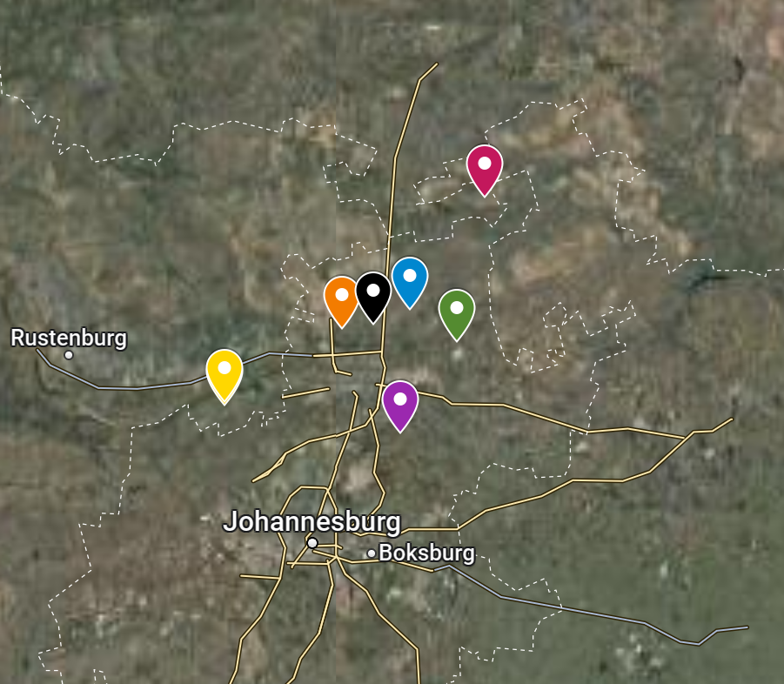
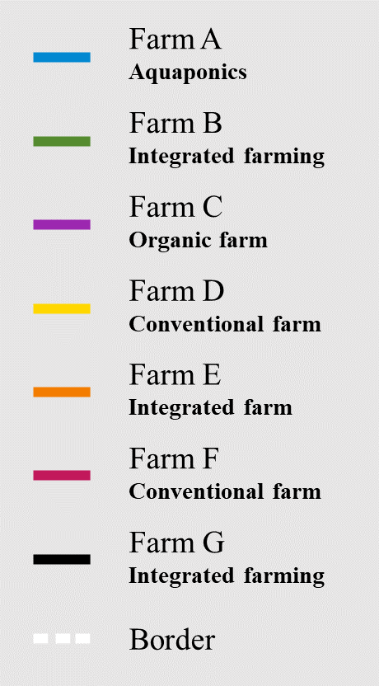
Figure 4.1: Map of South Africa showing the selected sampling sites for detection of Cryptosporidium in small-scale fresh produce production.
Table 4.1: Description of seven small-scale farm sites including, farming practice, crop type sampled, and water source
Sampling  area | Province | Farming practice | Crop type sampled | Farm water source (irrigation method)
Farm A | Gauteng | Integrated Farming (Animal Husbandry) | Kale and spinach | Borehole water
 |  | Aquaponics | Lettuce | Aquaculture system
Farm B | Gauteng | Integrated Farming (Animal husbandry) | Kale, spinach, and rape | Borehole water
Farm C | Gauteng | Organic Farming | Lettuce, radishes, and rocket | Borehole water
Farm D | Northwest | Conventional Farming | Baby carrots, leeks, spring onions, and rocket | River water
Farm E | Limpopo | Integrated Farming (Animal husbandry) | Tomatoes, green peppers, and spring onion | Dam water
Farm F | Gauteng | Conventional Farming | Spinach, green peppers, and onions | Municipal water
Farm G | Gauteng | Integrated Farming (Animal husbandry) | Peas | River water

4.2.2 Study area description
Four of the selected farms (farms A, B, E, and G) engaged in integrated farming practices, which synergistically combined farming activities to produce fresh produce and livestock, poultry, or fish (Figure 4.2). In each farming scenario, manure from the livestock (Farm A, B, E, and G) and fish (Farm A) produced on the farm was used to fertilise the crops. In addition to the manure-amended fertiliser, farm G also used commercially available fertiliser. Farms A and B used borehole water, while farms E and G used dam and river water, respectively, for irrigation purposes. More specifically, Farm A, an aquaculture farm, pumped borehole water into the aquaculture system containing fish to produce nutrient-enriched water to hydroponically irrigate lettuce. Additionally, borehole water from Farm A was used with rabbit and chicken manure-amended soil to water and fertilise kale and spinach. Farm B applied pig manure amendment as fertilisation with overhead irrigation. Farm C employed organic farming methods, utilising only borehole water, applied via overhead sprinklers, and plant-based fertilisers to produce a variety of fresh produce in an open field. Farm D and F practised conventional farming methods, utilising river water and municipal water, respectively, to solely produce fresh produce. Farm F used liquid fertiliser to primarily fertilise the crops, however, in some cases, chicken manure was also used (Figure 4.2).

Water system
Amendments
Fresh Produce field
Farm D
North canal
(supplied by river water)
Holding dam
South canal
(supplied by river water)
Holding dam
Open field:
Rocket, spring onions, and leeks
Open field:
Baby carrots
Overhead irrigation
Overhead irrigation
Farm B
Borehole water
Pig & chicken manure
Open field:
Chinese spinach, rape, and kale

Overhead irrigation
Borehole water
Plant-based fertiliser
Open field:
Lettuce, radish, and rocket
Overhead irrigation
Farm C
Farm E
Dam
Cow manure
Open field:
Tomatoes and spring onion
Canal
Holding dam
Net covered field:
Green peppers
Cow manure
Overhead irrigation
Drip irrigation
Hosepipe
Farm A
Borehole water
Nutrient-rich water
Chicken & rabbit manure
Aquaponic system to holding tank
Net covered field:
Kale and spinach
Hydroponics:
Lettuce
Nutrient-rich water
Hydroponically in canals
Farm F
Municipal water
Overhead tank
Open field:
Onions
Net covered field:
Green peppers and spinach
Chicken manure
Liquid fertiliser
Chicken manure
Liquid fertiliser

Drip irrigation
Overhead irrigation
River water
Chicken & cow manure + sawdust
2-3-4 fertiliser
Open field:
Peas
Overhead irrigation
Farm G

Figure 4.2: Description of water-plant-soil relationship on each of the selected farms.

4.2.3 Sample collection
Sample selection and collection of each sample type (water, soil, and fresh produce) was done based on the availability of each sample and the farming scenario (Table 4.2). A total number of 210 samples were collected from seven selected small-scale farms in the Gauteng, Northwest, and Limpopo Provinces. This included water samples at the source (n=22); soil samples at harvest (n=90 composite samples); and fresh produce samples at harvest (n=98). Each sample was transported in a cooler box at 4 ⁰C until analysis within 24 hours in the laboratory.

Water. From each farm, 100L of water (i.e., river, borehole, canal, or holding dam) was collected from the water source and/or irrigation water source and filtered through a kidney dialysis ultrafilter (Isigidi Medical Supplies (PTY) LTD, Centurion, SA) (FDA 2021).

Soil. Soil was simultaneously collected in sterile containers from five replicate points during harvest from the fresh produce production fields. Soil samples (15g), comprised of three subsamples each, were collected at each of the five replicate fresh produce sampling points in the field.

Fresh produce. Based on availability, at least three different types of fresh produce samples were collected at harvest from each respective farm (n = 98), except Farm G, which only had peas available. For each type of fresh produce, five samples were collected, consisting of three composite samples. These samples were obtained using a 70% ethanol-sterilised knife, employing systematic random sampling across rows in the farm field. The samples were then placed in labelled paper bags for transportation.

Table 4.2: Total number of samples collected at seven small-scale farm sites including, water, fresh produce, and soil samples
Farm | Farm water and irrigation source | Fresh produce | Soil | Total number of samples
Farm A | Water source 1: Borehole water in duplicate | Kale (n=5)  Spinach (n=5) | Soil (n=5) | n=23
 | Water source 2: Aquaponic system output water in duplicate | Lettuce (n=3) | Hydroponically grown
 | Water source 3: Fish Water
Farm B | Water and irrigation source 1: Borehole water in duplicate | Kale (n=5)  Spinach (n=5)  Rape (n=5) | Soil (n=5)  Soil (n=5)  Soil (n=5) | n=32
Farm C | Water and irrigation source 1: Borehole water in duplicate | Lettuce (n=5)  Radishes (n=5)  Rocket (n=5) | Soil (n=5)  Soil (n=5)  Soil (n=5) | n=32
Farm D | Water source: North River in duplicate |  |  | n=46
 | Irrigation source 1: North holding dam | Baby carrots (n=5) | Soil (n=5)
 | Water source 2: South River in duplicate
 | Irrigation source 2: South holding dam | Leeks (n=5)  Spring onions (n=5)  Rocket (n=5) | Soil (n=5)  Soil (n=5)  Soil (n=5)
Farm E | Water and irrigation source 1: From pump house in duplicate | Tomatoes (n=5)  Green peppers (n=5)  Spring onion (n=5) | Soil (n=5)  Soil (n=5)  Soil (n=5) | n=32
Farm F | Water source 1: Municipal water in duplicate |  |  | n=34
 | Irrigation source 1: Overhead tank in duplicate | Spinach (n=5)  Green peppers (n=5)  Onions (n=5) | Soil (n=5)  Soil (n=5)  Soil (n=5)
Farm G | Water source 1: River water | Peas (n=5) | Soil (n=5) | n=11

4.2.4 Sample processing
Water. The ultrafilter was backflushed with a 2.5 L solution containing sterile water supplemented with 0.5% Tween 80. After filtering the filtrate through a 0.45 µm nitrocellulose membrane (Sartorius, Johannesburg, SA), the membranes were aseptically cut and placed into labelled falcon tubes containing 9 mL of 0.1% buffer peptone water (BPW) (3M, Minnesota, USA). Thereafter, the tubes were vigorously vortexed (ZX3 Advanced vortex mixer, Velp Scientifica, Italy) and centrifuged for 10 mins at maximum speed (Micro Analytica (Pty) Ltd, Pretoria, SA). After discarding the supernatant, the pellet was resuspended in 1ml distilled water and centrifuged for 1 min. The previous step was repeated, and the pellet was resuspended in 100 µl of phosphate buffered saline (PBS) (Oxoid, Hampshire, UK) and used for DNA extraction.

Soil. The soil samples collected from each farm were processed within 24 hours after collection for molecular analysis. For each sample, 0.25 g was aseptically added to Eppendorf tubes and used for DNA extraction according to the manufacturer’s instructions.
Fresh produce. After weighing 50g of each respective fresh produce sample, the sample was placed in a labelled, sterile polyethylene strainer stomacher bag (Seward Ltd., West Sussex, UK) containing 200 ml 0.1% BPW (3M) supplemented with 0.01% Tween-80 in a 1:4 weight-to-volume ratio (Berrouch et al., 2020b). Individual fresh produce samples were homogenised for 30 sec at 250 rpm in a Homogeniser Laboratory Blender (ThermoFisher Scientific, Massachusetts, USA), and the homogenised sample mixtures of each sample were poured into a 50ml Falcon tube and centrifuged in a Sigma 2-16KL (Lasec SA (Pty) Ltd, Midrand, SA) at 2500 x g for 10 min. The supernatant was carefully removed and discarded, and the previous step was repeated until all the biomass was centrifuged. The pellet was resuspended in 1ml double distilled water and centrifuged at 10000 rpm for three min. After repeating the previous step once more, the pellet was resuspended in 300 µl of PBS (Oxoid, Hampshire, UK), and the sample was used for DNA extraction.

4.2.5 DNA extraction
DNA extraction methods for each sample type were chosen based on the validated workflow determined in Chapter 3.

Water. DNA was extracted using the DNeasy Blood and Tissue Kit (Qiagen, Hilden, Germany) as described by the manufacturer’s recommendation with an additional lysis step as previously described (Mthethwa et al., 2022; Chapter 3). The samples were suspended in 500 μl of lysis buffer (10 mmol/L Tris/HCl pH 8.0, 10 mmol/L EDTA, 0.1 mol/L NaCl, 2% SDS, pH 8.0, and 100 μl protease K) followed by incubation for 2 h at 55 °C - 60 °C (Djurhuus et al., 2017; Awolusi, 2016; Mthethwa et al., 2022). The remainder of the DNA isolation protocol was followed according to the DNeasy Blood and Tissue Kit manufacturer's instructions.

Fresh produce and soil. DNA was extracted using the DNeasy PowerLyzer DNA Isolation Kit (Qiagen) according to the manufacturer’s recommendation with an additional lysis step published by Mthethwa et al. (2022). The samples were transferred into the bead tubes provided by the DNeasy PowerLyzer Kit and suspended in 500 μl of lysis buffer (10 mmol/L Tris/HCl pH 8.0, 10 mmol/L EDTA, 0.1 mol/L NaCl, 2% SDS pH 8.0, and 100 μl protease K) followed by incubation for 2 h at 55 °C - 60 °C (Djurhuus et al., 2017; Awolusi, 2016; Mthethwa et al., 2022). The remainder of the DNA isolation protocol was followed according to the DNeasy PowerSoil manufacturer's instructions.
Following DNA extraction, the concentration of each sample was determined using the Qubit dsDNA High Sensitivity Assay and a Qubit 2.0 fluorometer (Life Technologies, California, USA). In addition, the purity was determined using the Nanodrop 2000 (ThermoFisher Scientific) according to the manufacturer’s instructions.

4.2.6 Molecular detection of Cryptosporidium

4.2.6.1 Real-time PCR analysis
The presence/absence of Cryptosporidium was determined using the PrimerDesign™ Genesig Standard Kit for Cryptosporidium (Crypto) Genomes (PrimerDesign™, Chandler's Ford, UK) and PrecisionPLUS qRT-PCR Mastermix (PrimerDesign™). The PCR reaction mixture was prepared according to the manufacturer’s instructions to a final volume of 20µl. Positive and negative controls as provided in the kit were included in the qPCR assay. The thermocycling conditions were as follows: 95°C for two min, followed by 50 cycles of 95°C for 10 s and 60°C for 60 s. Data was collected from the green (FAM) channels during each 60°C annealing/extension phase, and the Bio-Rad CFX Connect Real-Time PCR Detection System (Bio-Rad, Hercules, California, USA) was used for post-run analysis.

4.2.6.2 Droplet-digital PCR analysis
The ddPCR amplification protocol was optimised as previously described in Chapter 3. The ddPCR was used for the detection and quantification of Cryptosporidium. Each reaction mixture contained 13 µl of Bio-Rad supermix for probes (no dUTP) (Bio-Rad), 1.5 µl of primers/probes Cryptosporidium mix included in the PrimerDesign™ Genesig Standard Kit, 4.5 µl of nuclease-free water, and 7 µl of template DNA to make a final volume of 26 µl ddPCR assay sample. PCR reaction partitioning and droplet generation were performed using the QX200 Droplet Generator (Bio-Rad) with Bio-Rad droplet generation oil for probes. PCR amplification was carried out on a T100 thermal cycler (Bio-Rad) under the following conditions: 95°C for two minutes, followed by 50 cycles of denaturation at 95°C for 10 seconds, annealing at 57°C for 60 seconds, and a final extension at 72°C for 10 minutes. The QX200 Droplet Reader and QuantaSoft software (Bio-Rad) were used to read and analyse the reactions. A positive control and no template control (NTC) were also included in the reaction, and the threshold line was established based on the separation of negative and positive droplets.

References
Awolusi, O.O., 2016. Evaluation of seasonal impacts on nitrifiers and nitrification performance of a full-scale activated sludge system [Doctoral dissertation, Durban University of Technology].
Berrouch, S., Escotte-Binet, S., Harrak, R., Huguenin, A., Flori, P., Favennec, L., Villena, I. and Hafid, J., 2020b. Detection methods and prevalence of transmission stages of Toxoplasma gondii, Giardia duodenalis and Cryptosporidium spp. in fresh vegetables: a review. Parasitology, 147(5), pp.516-532.
Djurhuus, A., Port, J., Closek, C.J., Yamahara, K.M., Romero-Maraccini, O., Walz, K.R., Goldsmith, D.B., Michisaki, R., Breitbart, M. and Boehm, A.B., 2017. Evaluation of filtration and DNA extraction methods for environmental DNA biodiversity assessments across multiple trophic levels. Frontiers in Marine Science, 4, p.314.
Mthethwa, N., Amoah, I., Reddy, P., Bux, F. and Kumari, S., 2022. Development and evaluation of a molecular based protocol for detection and quantification of Cryptosporidium spp. in wastewater. Experimental Parasitology, 234, p.108216.

Appendices

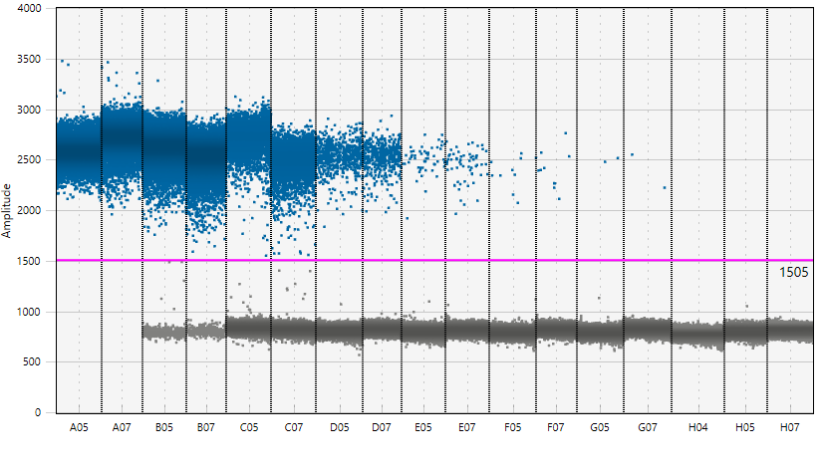
Appendix A:
Figure A1: Figure of droplet separation shown and serial dilution of positive reference DNA.

